**ORDER BY, GROUP BY, HAVING**

create table customer_exp8_csa_46(customer_id int,customer_Name varchar(20),contactNo number(10),Address varchar(20),city varchar(20),postalcode varchar(10),country varchar(20),primary key(customer_id));

desc customer_exp8_csa_46;

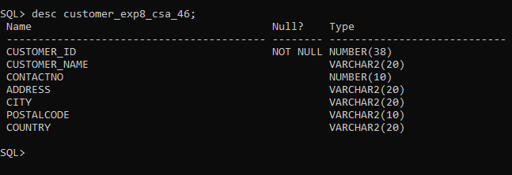

create table employee_exp8_csa_46(employeeid int,lastname varchar(20),firstname varchar(10),birthdate date,photo varchar(2),primary key(employeeid));

desc employee_exp8_csa_46;

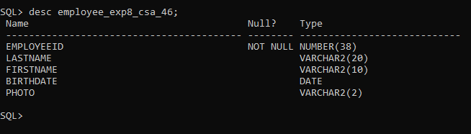

create table orders_exp8_csa_46(orderid int,customer_id int,employeeid int,orderdate date,shipperid int,primary key(orderid),foreign key(customer_id) references customer_exp8_csa_46(customer_id),foreign key(employeeid) references employee_exp8_csa_46(employeeid));

desc orders_exp8_csa_46;

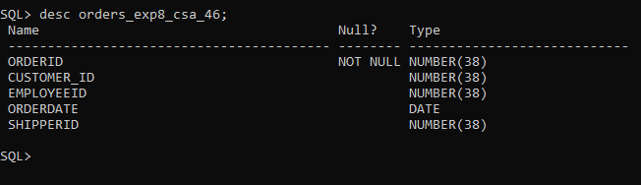

insert into customer_exp8_csa_46 values(1,'Naveen',7558040803,'Skyline Apartment','Kottayam',686016,'India');

insert into customer_exp8_csa_46 values(2,'kevin',7558040800,'Jewel Apartment','Manipuzha',686017,'India');

insert into customer_exp8_csa_46 values(3,'Nandu',7558040206,'Chandys Apartment','Baker JN',686018,'India');

insert into customer_exp8_csa_46 values(4,'Neha',9558040206,'Capetown Apartment','Pala',686019,'India');

insert into customer_exp8_csa_46 values(5,'Alex',6001245568,'High Towers','LA',600151,'Usa');

select * from customer_exp8_csa_46;

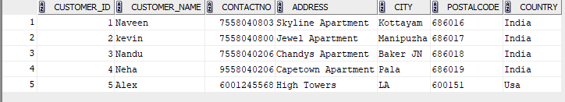

INSERT INTO EMPLOYEE_EXP8_CSA_46 VALUES(10,'Jake','Paul','31/12/2003',NULL);

INSERT INTO EMPLOYEE_EXP8_CSA_46 VALUES(11,'Jack','Raugh','01/11/2002',NULL);

INSERT INTO EMPLOYEE_EXP8_CSA_46 VALUES(12,'Joseph','Bennet','28/12/2001',NULL);

INSERT INTO EMPLOYEE_EXP8_CSA_46 VALUES(13,'Brown','Chris','11/12/2003',NULL);

INSERT INTO EMPLOYEE_EXP8_CSA_46 VALUES(14,'Beiber','Justin','27/08/2000',NULL);

INSERT INTO EMPLOYEE_EXP8_CSA_46 VALUES(15,'Stone','Emma','27/08/1985',NULL);

select * from EMPLOYEE_EXP8_CSA_46;

